eBlessings International Daily Devotional Archives
enrich, inspire, encourage, bless, and empower spiritual warriors for end-time battles prepared with the guidance of the Holy Spirit for spiritual growth and victory! Devotionals Designed to Empower and Grow Our Spirits
DECEMBER 2009 DECEMBER 2009 DECEMBER 2009
Visit DOT, and WOW Empowerment Series, plus Prophecy, Spiritual Keys & Lessons, IA, PP and more...

Each One! Bless One!
You Make a Difference!

* * * * *

Dear Brothers and Sisters,

First of all we welcome you here in Rumangabo / Goma - North Kivu Province, Congo RDC to come to help us train ministers and believers through seminars and conferences. We ask You to help us feeding these orphans when at school also. We come to You to ask a help to allow us to build 8 classrooms and an office for orphans and children from poor families.
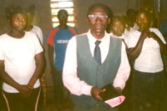

In Christ, Rev. John Paul Munganga
(jcmegaapd777@yahoo.com)
+243994287078 +243853447876

Here is the proposal.

PROPOSAL

TITLE: Construction of 8 classrooms for the Spirit and Word School Complex and Office for orphans and children from poor families.
1. Domain: Objective--Protection of children, prevention of child delinquency.
2. Place of carrying out / Groupement de Kisigari / Collectivite de Bwisha, Rutsuru Territory, North Kivu Province-Congo RDC.
3. Sector: Education
4. Beneficiary: 170 children (50 orphans: parents killed during these wars here in Congo and other with HIV and others by other sicknesses / 120 from poor families)
5. Subordinate: APD / Mega Ministries Congo RDC, Rumangabo (45 miles from Goma )
6. Cost of the Project: 27,612$ (twenty seven thousand, six hundred and twelve dollars)
7. Amount needed: 23,612$ (twenty three thousand, six hundred and twelve dollars)
8. Contribution towards Costs: 4,000$ (four thousand dollars)

I . Problematic

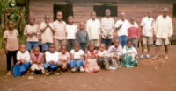
Our Country Congo RDC come from many wars since 1996 wars which caused may problems, people killed, houses destroyed and many people lost their things and are now poor and live traumatized lives. Now Rumangabo is just in the area which had been attacked many times. Because of these people coming from many villages which had been so insecure and not safety to live. Then they run and came to live at Rumangabo where the life is now easy for them and far from insecure zones. The situation of the villages just near the Virunga Park caused them to be attacked by FDLR and other rebels troops.

Because of these wars many parents had been killed and now the city had many orphans who can not study easily and widows who are unable to pay for their school fees.

II. Justification

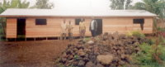
The Spirit and Word School Complex assisted by the Rev. John Paul Munganga, the Founder by the Grace of God of the APD / MEGA Ministries, a Soul-winning Ministry and which also lead some churches where there is no Christian Churches in rural villages; built two classrooms for the orphans and children from poor families. From P1 we have now students in P2, P3 and P4. Others are studying in the local church divided by a tent.

The number had increased now and we need more classrooms and good ones where the children may study in good conditions with benches. The population is not able to bring money so that we may build even those families where the orphans had been welcomed are not able to help us to build. We need to build 8 classrooms and an office for the Director of the school.
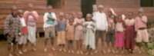
III. Impact of the Project

By building the school this will help our population because of the big numbers of orphans who will start to study and reduce the children delinquency. The hope is our children will study in good conditions and increase their population in the classrooms. The school will reduce the number of children who stay at home and people will get jobs.

IV. Objectives

1. Global Objective
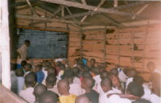
Sustain the community to the normal life, promote the life of the orphans and children from poor families to study in good conditions for a better future.

2. Specific Objectives

We will get good school and good classrooms, where the children will study in good conditions and a good place where the Youth can be trained spiritually and physically with a good level of studying. The place will help also as a good place for peace. We will insure good training for children and promote studies for orphans and children from poor families.

V. Beneficiary

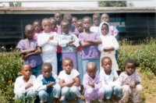
The population: students (170) and teachers (8) and people who will work there -- 120 (Directs) Rumangabo Population, Kabaya, Katale, Rugari, Mushoro, Kalengera and Rubare villages.

VI. Description of the Project

We will need to build 8 classrooms with an office for the Director of the school. We will contact officials to assist us for the promotion of the school. We will call local people here to work as their participation. We will need to equip those classrooms by benches, blackboard, tables and chairs for teachers.

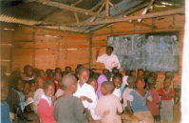
Activities

- Mobilize the beneficiary population
- identification and the selection of people in needs so that they may also join us by sending the children to school
- Build the classrooms

The Calendar
From January 2010 - April 2010

Budget
- 300 Iron sheets ------------------------------------------------------2500$
- 1000 Planks------------------------------------------------------------2500$
- 500 Timbers------------------------------------------------------------ 750$
- 50 Sacks of cement------------------------------------------------- 1250$
- Ceiling------------------------------------------------------------------ 450$
- Stones------------------------------------------------------------------ 700$
- Lime-------------------------------------------------------------------- 500$
- Sand-------------------------------------------------------------------- 400$
- Nails---------------------------------------------------------------------- 30$
- 8 Tables----------------------------------------------------------------- 400$
- 8 Chairs----------------------------------------------------------------- 130$
- 160 Benches----------------------------------------------------------- 8000$
- 8 Blackboards---------------------------------------------------------- 180$
- Water--------------------------------------------------------------------- 500$
- Partial Total -----------------------------------------------------------22090$
- Labor ---------------------------------------------------------------------4418$
- Unexpected -------------------------------------------------------------1104$
- GLOBAL TOTAL -----------------------------------------------------27,612$
(Twenty Seven Thousand, Six Hundred and Twelve Dollars)

PDF Copy for Friends and Family (printing style: booklet)
DOC Copy for Friends and Family (print two pages per sheet)

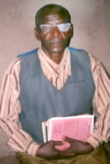
Rev. John Paul Munganga
(jcmegaapd777@yahoo.com)
+243994287078 +243853447876
Rev. Bazamanza Bernard, Coordinator
APD / MEGA Ministries Congo RDC
SCEP / Ushindi-Rumangabo
North Kivu Province
P.O. Box 574 Gisenyi, Rwanda
(Devotional from 2 February)

