eBlessings International Daily Devotional Archives
enrich, inspire, encourage, bless, and empower spiritual warriors for end-time battles
prepared with the guidance of the Holy Spirit for spiritual growth and victory!
Devotionals Designed to Empower and Grow Our Spirits
IDD 2004 | IDD 2005 | IDD 2006 | IDD 2007 | IDD 2008 | IDD 2009
JANUARY 2009 JANUARY 2009 JANUARY 2009
Visit DOT, and WOW Empowerment Series,
plus Prophecy, Spiritual Keys & Lessons, IA, PP and more...

Each One! Bless One!
You Make a Difference!

* * * * *

ART WALK! at The Neighborhood Gallery
2001 Magazine St. New Orleans , LA * (504) 251-8013
Saturday February 7th 2009

Showcasing Works by:
Ronald Jones  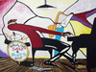  All Night Jazz | John Slade  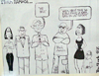  My Bad
Latifah Ali  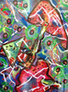  Pieces of a Dream No. 2 | Raymond Gaines  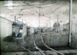  Street Car Yard

Introducing Works by:

Stephanie Stallmer  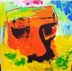  Super Ego | Ann Cooper  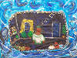  At the Neighborhood Gallery
Carter King  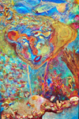  Found at Sea | Karin Rittvo  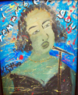  I Remember You

Join us for conversation & Networking!
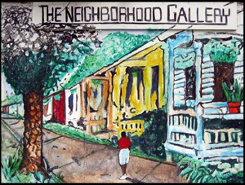
The Neighborhood Gallery
2001 Magazine St
New Orleans , LA
(504) 251-8013

