eBlessings International Daily Devotional Archives
enrich, inspire, encourage, bless, and empower spiritual warriors for end-time battles
prepared with the guidance of the Holy Spirit for spiritual growth and victory!
Devotionals Designed to Empower and Grow Our Spirits
IDD 2004 | IDD 2005 | IDD 2006 | IDD 2007 | IDD 2008 | IDD 2009
JANUARY 2009` JANUARY 2009 JANUARY 2009
Visit DOT, and WOW Empowerment Series,
plus Prophecy, Spiritual Keys & Lessons, IA, PP and more...

Each One! Bless One!
You Make a Difference!

* * * * *

My Dear Precious Friend, I pray that you have
an even more blessed and fruitful year in 2009 than ever before.

“And Jesus went about all the cities and villages, teaching in their synagogues, and preaching the gospel of the kingdom, and healing every sickness and every disease among the people. But when he saw the multitudes, he was moved with compassion on them, because they fainted, and were scattered abroad, as sheep having no shepherd. Then saith he unto his disciples, The harvest truly is plenteous, but the labourers are few; Pray ye therefore the Lord of the harvest, that he will send forth labourers into his harvest.”
MATTHEW 9:35-38 (KJ)

My Dear Precious Friends,
I am sorry I could not bring you December update on time due to ministry visit all around the country. I do hope you had blessed year in 2008 and I pray that you would have even more blessed and fruitful year in 2009. It is really a great to work together. I would like to thank God for giving me one more year in my life to do ministry. 2009 is year of ministry for me.
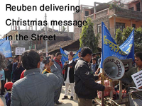
In this year, I will do ministry like I did never before. I will preach the gospel of Jesus Christ from top of the world and to all the way around. If God will, I will bring many people from darkness to light and from power of Satan unto God. I need your prayers and I need your support. From your prayer, comes my strength.
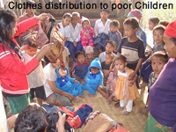
In December of 2008, through the empowerment of the Holy Ghost we were able to do many works and one of them was Clothes Distribution. We distributed Jackets, Trousers, Sweeter, Caps, Gloves and Shoes and other items. Children were so glad, they were smiling. There were 43 Children who received, but there were still other children who did not get. I guess 100 dollars should be enough to provide clothes for remaining. We also ran Two Week Music Class for worship leaders wishing to learn more about music. There were 20 participants. Now they are teaching their member how to worship.

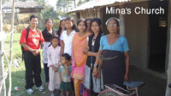
We visited Mina's Church. We are glad that she is having fellowship with some of her new believers. I promised her to help start a Church for 6 months which I did. I help paid rent for 6 months. Please pray that she would be able to continue the work.

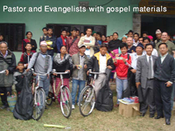
Thank you for praying for our Annual Conference. Believers from all over Nepal had gather for a refreshment. Every Church gave their annual statistics. They were ministered, uplifted, and encouraged. Many went back with new commitment. Holy Spirit performed wonderful works in the conference. We also were able to give Bicycles to local Evangelists and Pastors, Bibles were given to Churches for new converts, Tracts were given to believers to use in Evangelism and Guitars were given to help in outreach and to some mobile phone to communicate.

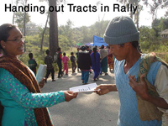
Thank you for your prayers and thank you for your support. I look forward to receive more prayer and support from you in 2009. We would like to plant 7 Churches in 2009, if God wills.

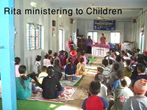
We had two programs in Gaighat, Leadership Conference and Christmas Rally. We ministered in conference in a new Church which did not have roof. Speakers do not often travel in those areas and they were happy enough to host us. Hotel we stayed did not have enough water and we fought with mosquitoes at night. Next day was rally and it was huge. There were around 1,000 children and adults in parade from 22 Churches with banners and cards about birth of Jesus. In most areas, churches and leaders do not unite for big event, but in Gaighat all Christian faith people united for the events and which brought glory to God. Gospel was preached, a woman possessed with demon was released in front of huge crowd and many were ministered.
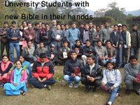
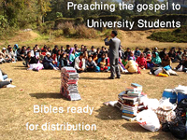
We made Christmas a medium to tell Universities’ students about 'why Jesus was born'. I preached on three reasons why Jesus had to be born in this world. Christmas with University Students was very much fruitful. There were around 70 who came and many of them heading towards their PHD’s in foreign countries. And now 4 of them are coming to the Church. Bibles were distributed to these wonderful people. Many of them were very much curious to know about Jesus. The English Bibles were received free of charge from Christian Resource International in USA to which we are so thankful. CRI we continue to look for your help in the future.

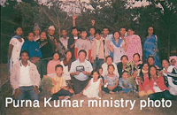
Sixteen (16) people accepted Jesus Christ in three different places in December. Two new fellowships were started in two new places and 12 people were baptized in water in two Churches. Purna, Mani, Chitra and Bikash are visiting village to village and house to house to carry out the gospel and they have requested us more Gospel Tracts and Bibles for their evangelism.

Prayers: We have two weeks Bible School in March and conferences. Please pray that I have motorbike soon with helmet, leather jacket, gasoline, license and paper and every thing related with it. I am praying for a good Laptop for me for my personal use while traveling for ministry. Laptop would help me so much to preach and perform. 2009 is my year of ministry; I will make myself very busy in the Lord's work this year. Some time you may get update late. I do need your prayer. Please mention Bible School, motor bike and a laptop for me.
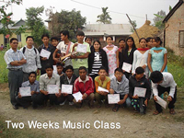
I am making a 12 minute Video presentation of our ministry and newsletter and I would like to send it to you. Please let me know your postal address if they are changed. Together we did wonderful work in 2008 in Nepal for God, now let's work together toward changing Nepal. Lets remember that the harvest is large, but there are few workers to gather it in. (Matthew 9:37).

THE HARVEST IS RIPE

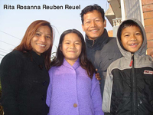
Pastor and Mrs. Reuben and Rita Rai,
Miss Rosanna Rai, Master Reuel Rai
Balkumari Apostolic Mandali
GPO 8975 EPC 2030
Kathmandu, Nepal
Email: tankrai@gmail.com, reubenrita@yahoo.com
www.churchesnetwork.com / www.freewebs.com/reubeninnepal
Phones: (0977) 98510 12105, (0977) 9841618428

