eBlessings International Daily Devotional Archives
enrich, inspire, encourage, bless, and empower spiritual warriors for end-time battles
Devotionals Designed to Empower and Grow Our Spirits

JANUARY2010JANUARY2010JANUARY2010
IDD 2004 | IDD 2005 | IDD 2006 | IDD 2007 | IDD 2008 | IDD 2009 | IDD 2010
Visit DOT, and WOW Empowerment Series, plus Prophecy, Spiritual Keys & Lessons, IA, PP and more...

Each One! Bless One!
You Make a Difference!

* * * * *

School of Evangelism and Church Planting

About Nepal
Nepal is the home of Mount Everest and also land of beauty but lives in deep spiritual darkness. Only the 2% of the 27 million people have professed Jesus as their personal Lord and Savior and the rest are waiting to hear the Gospel of Jesus Christ. Hinduism is the dominant religion followed by Buddhism. Much preaching was done in the last ten years so the conversion of new souls has grown to certain numbers. (People cannot ignore our numbers.) Nepal is bordered with China's Tibet in the North and to India in the South.

The Need of the Bible School
School of Evangelism and Church Planting trains and equips the Saints for the work of the ministry. Jesus tells us that 'Go ye therefore, and teach all nations, baptizing them in the name of the Father, and of the Son, and of the Holy Ghost', Mathew 28:19.

People here worship trees, idols, rivers, stones and animals because they do not know the Creator. We know their need to hear the Gospel and if we do not preach the Gospel and they go to hell then God will hold us accountable for their souls. We must witness Jesus to them. The Bible says that "For whosoever shall call upon the name of the Lord shall be saved. How then shall they call on Him in whom they have not heard? And how shall they hear without the preacher? And how shall they preach except they be sent? As it is written, how beautiful are the feet of them that preach the gospel of peace, and bring glad tidings of good things!" Every year we train people that want to do ministry and send them to the evangelism work and for church planting. Bible school graduates have brought numerous souls to the kingdom of God. If we ever dream to win our country to Jesus then we must produce faithful laborers. Where ever I go believers they ask me 'when are you going to have Bible school again so that I might attend also'. People they want to attend School so that they might go and do ministry.

Bible School 2010
We are planning to have a 4th Bible School in April this year. Here is the approximate expenses, please pray for us. Every single dollar is highly appreciated. We are planning to have 25 students and the duration of this is one month. Expenses in Nepali Rupees.
- Food (breakfast, lunch and dinner, 200 rupees per a day per person) --150,000
- T-shirt and some sleeping items -- 18,000
- Bibles and tracts (5 Bibles and 1,000 tracts for each person) --50,000
- Other 3,000
- Total 221,000 rupee; (3,112 dollars)

Expectations
In Nepali Rupees
- Registration money 12,500
- Special offering from the local churches 22,500
- Total 35,000 rupees; (492 dollars)
Please pray that God will supply us 186,000 rupees or 2,620 US dollars for the school in 2010. (Exchange rate: 1 US dollar = 71 Nepali Rupees)

Bible School Impact
I would like to tell the ministry biography of Purna Kumar. He was student in 2007 Bible school. He went back and in 3 years time started churches in three different places, in Mahamai, Dasami and in Kerkha. In these three new churches there are more than 100 new converts. Some of them are joining the Bible School this season.

THANK YOU
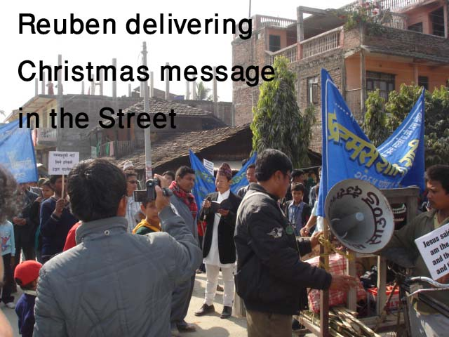
Pastor Reuben Rai
School of Discipleship, Evangelism and Church Planting
Balkumari Apostolic Mandali
GPO 8975 EPC 2030
Kathmandu, Nepal
Email: tankrai@gmail.com, reubenrita@yahoo.com
www.churchesnetwork.com / www.freewebs.com/reubeninnepal
Phones: (0977) 98510 12105, (0977) 9841618428

