eBlessings International Daily Devotional Archives
enrich, inspire, encourage, bless, and empower spiritual warriors for end-time battles
prepared with the guidance of the Holy Spirit for spiritual growth and victory!
Devotionals Designed to Empower and Grow Our Spirits

JULY 2008 JULY 2008 JULY 2008
Visit DOT, and WOW Empowerment Series,
plus Prophecy, Spiritual Keys & Lessons, IA, PP and more...
Each One! Bless One!
You Make a Difference!

* * * * *

Our righteousness is not our own. Our unrighteousness is not our own. Our righteousness is like filthy rags. When in Christ, our righteousness is Christ Righteousness.

“For they be ignorant of God’s righteousness, and going about to establish their own righteousness, have not submitted themselves unto the righteousness of God.”
ROMANS 10:3 (KJ)
“Who his own self bare our sins in his own body on the tree, that we, being dead to sins, should live unto righteousness: by whose stripes ye were healed.”
1 PETER 2:24 (KJ)

DEATH – 4. Please see Death -1, Wednesday, 2 July; Death -2, Sunday, 6 July; Death -3, Sunday, July 13, 2008. Let us take a look at “death.”

Death believed that Jesus’ Death would take Him (Jesus) be off the spiritual playing field of earth, being ushered back to Heaven by Death. Boy was Death surprised when Jesus came and took Death’s authority, control, and power. And likewise Hell thought that Jesus was taken off the spiritual playing field only to realize the Jesus ushered in the Kingdom of Christ to stay forever on the playing field and to have complete dominance and sharing that dominance with His—those called by His name—Christians.

Please note, that Jesus transformed the “death experience” from a torturous one, (know this, hell was transformed too) to one of “eternal life” in Christ, to those who believe in Christ. So Jesus changed “death,” from a finite physical end landing you in a torturous hell experience or one landing you in the bliss of Heaven depending on God’s Grace and Mercy—to an ‘eternal” experience in Christ for all—all in Christ.

Now the theological debate is whether Jesus allows everyone in Heaven after His Crucifixion, because of this verity: Jesus would that all be saved. “For this is good and acceptable in the sight of God our Savior; Who will have all men to be saved, and to come unto the knowledge of the truth.” 1 Titus 2:4 (KJ) “For it is written, As I live, saith the Lord, every knee shall bow to me, and every tongue shall confess to God.” Romans 14:11 (KJ) (Prophesy: Isaiah 45:23) But how can that be so—Our Righteousness is that of Christ. We put on the Righteousness of Christ. (a Giant Key). Our righteousness is not our own. “Neither yield ye your members as instruments of unrighteousness unto sin: but yield yourselves unto God, as those that are alive from the dead, and your members as instruments of righteousness unto God.” Romans 613 (KJ) Look for Death – 5.

OUR UNRIGHTEOUSNESS IS NOT OUR OWN
CHRIST = OUR RIGHTEOUSNESS

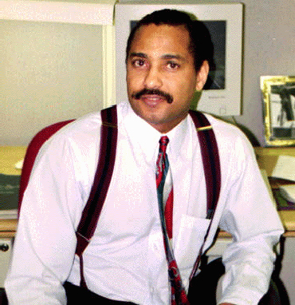
James Anthony Allen, Evangelist
eBlessings Founder
Stone Mountain, Georgia, USA, North America
Email: eblessings@gmail.com

“For as by one man’s disobedience many were made sinners, so also by one Man’s pbedience many will be made righteous. Moreover the law entered that the offense might abound. But where sin abounded, grace abounded much more, so that as sin reigned in death, even so grace might regn through righteousness to eternal life therought Jesus Christ our Lord.”

