eBlessings International Daily Devotional Archives
enrich, inspire, encourage, bless, and empower spiritual warriors for end-time battles
prepared with the guidance of the Holy Spirit for spiritual growth and victory!
Devotionals Designed to Empower and Grow Our Spirits

JULY 2008 JULY 2008 JULY 2008
Visit DOT, and WOW Empowerment Series,
plus Prophecy, Spiritual Keys & Lessons, IA, PP and more...
Each One! Bless One!
You Make a Difference!

* * * * *

Is there any by-product of unclean spirit infestation which can negatively impact our lives, our environments, our homes, or our bodies? If so, how?

“And an angel of the LORD came up from Gilgal to Bochim, and said, I made you to go up out of Egypt, and have brought you unto the land which I swore unto your fathers; and I said, I will never break my covenant with you. And ye shall make no league with the inhabitants of this land; ye shall throw down their altars: but ye have not obeyed my voice: why have ye done this? Wherefore I also said, I will not drive them out from before you; but they shall be as thorns in your sides, and their gods shall be a snare unto you.. And it came to pass, when the angel of the LORD spoke these words unto all the children of Israel, that the people lifted up their voice, and wept.”
JUDGES 2:1-4 (KJ)

PETS – 1. Do not get angry with me, but listen. Why was the LORD so angry with Joshua who loved, long for, and longingly enjoyed the Presence of the LORD. Joshua a praying man, a holy man, but that is another story. I believe the reasons why God was so adamant for the Israelites to kill the men, women, children, and animals of the inhabitants of the Promised Land was because of the behavior of shepherds in the field with their flocks of sheep for weeks on end. The behavior in question is that of sexual perversion; sexual intercourse with sheep (Which is said to be the closet thing to having sex with a woman.)

If you can wrap your mind around that type of sexual perversion and think it is okay, let me go further. Remember, when the angels fell from Heaven (the demonic entities), they went into (hear: in some cases possessed) rocks, trees, animals, and other of God’s Creation as a way to “thumb their noses at” (disrespect God and) any part of His Creation. They were rescued by heavenly Angels. These entities also mated with people; Genesis 6:1-2. This is probably why the Flood was necessary.

Future generations had to deal with this same issue; this same model. But the problem you see is the demons, unclean spirits and other demonic creatures did manage to go into (hear: inhabit or live in) animals (perhaps due to the fact they have the four elements: earth, water, wind, and fire (body, blood, breathe, heart; respectively). As in Luke 8:30, “And Jesus asked him, saying, What is thy name? And he said, Legion: because many devils were entered into him.” There were many creatures in one living being.

So imagine, if you will, hundreds of unclean spirits in a sheep. After having intercourse with sheep, husband goes home to wife. He gives unclean spirits to wife. If the man is not married but promiscuous then he may give unclean spirits to countless women or just a few, but they in turn give the unclean experience to other guys. That is one way they spread in animals – in pets. The question is with pets—is there any by-products of unclean spirits’ infestation which can negatively impact our lives, our environments, our homes, or our bodies? If so, how? See Pets-2.

DEAL WITH UNCLEAN SPIRITS

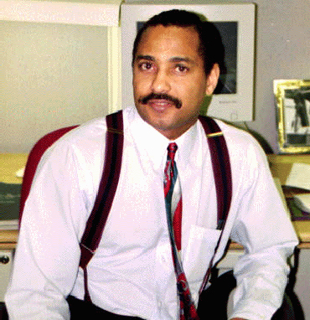
James Anthony Allen, Evangelist
eBlessings Founder
Stone Mountain, Georgia, USA, North America
Email: eblessings@gmail.com

