eBlessings International Daily Devotional Archives
enrich, inspire, encourage, bless, and empower spiritual warriors for end-time battles
prepared with the guidance of the Holy Spirit for spiritual growth and victory!
Devotionals Designed to Empower and Grow Our Spirits

JULY 2008 JULY 2008 JULY 2008
Visit DOT, and WOW Empowerment Series,
plus Prophecy, Spiritual Keys & Lessons, IA, PP and more...

Each One! Bless One!
You Make a Difference!

* * * * *

Stop giving “lip service” only; get involved.

“Children, obey your parents in the Lord: for this is right.”
EPHESIANS 6:1 (KJ)

“Children, obey your parents in all things:
for this is well pleasing unto the Lord.”
COLOSSIANS 3:20 (KJ)

What was it? You just gave yourself lip service. Example: Let’s say a child disrespects a parent. The parent who is the victim walks out of the picture. The child said something wrong. In the absence of the “victim” parent, the “authority” parent, the parent in authority says to the child, “What you said was wrong. And please refrain from like actions.” “Okay,” is the reply.

What happened here? The child acted inappropriately. The “authority” parent noted it (the inappropriate behavior), then commented on it. The “disobedient” child acknowledged the statement. The child left the room. Nothing happened here but the exchange of words and a teenage “hoky-doke” (take any advantage of a person or situation). No discipline—no exercise of authority happened here—only “lip service.”

The parent only acknowledged an inappropriate behavior. Then there was agreement that the behavior was inappropriate. The “authority” parent gave himself or herself “ear candy” (saying something that sounds good but has no real teeth). Otherwise known as “talking just to hear yourself speak.” They are just going through the motions of parenting without this:

- Say action is wrong, explain why and explain future consequences of such action, while considering present action (hear: disciple) now. And let the child know.
- Have the “disobedient” child apologize to the “victim” parent. This helps the child develop character and helps build relationship.
- Should the behavior and similar behavior show up again, then you, the parent have a plan. The child knows the consequences. What needs to happen is, if the behavior shows up again—handle it appropriately with a “discussed” action plan.

It is important not to do something just for the sake of doing it. Understand the “why” of doing it. Doing things without knowing the “why,” the purpose or direction is akin to the “blind following the blind.” Know why your family members and society have you doing what you do. Is it godly? Is it ungodly? When we understand the “why,” we have an opportunity not to miss out on the “zest of life” which resides in each action, thought, purpose, friend, family, and ________. You fill in the blank.

KNOW THE “WHY” OF CHRIST

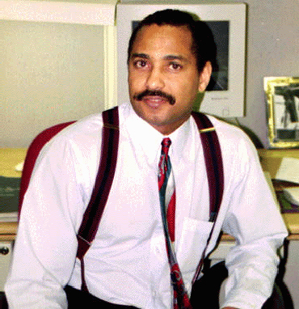
James Anthony Allen, Evangelist
eBlessings Founder
Stone Mountain, Georgia, USA, North America
Email: eblessings@gmail.com
(404) 735-7258

