EACH ONE! BLESS ONE! YOU MAKE A DIFFERENCE!
If Each One Will Bless One, the World as We know it Will Change!
Emmanuel’s Blessings to You! Peace and Love in Christ! PLC!
Visit the Seal-of-God, Four-N-One, Dot, Wow, Prophecy, Keys & Lessons, IA, PP and Welcome...

Each One! Bless One!

* * * * *

When we come to the realization that it's not the individual we struggle against, but the spirit that is controlling them we can shift our approach.

"Put on the full armor of God so that you can take your stand against the devil's schemes..."
EPHESIANS 6:11-17

Spiritual Soldiers. One of the realities we all come to is that sometimes we are in the right fight, but with the wrong people. We believe we are really at odds with a co-worker, another church member, or even the person we are in a relationship with. But when we come to the realization that it's not the individual we struggle against, but the spirit that is controlling them we can shift our approach.

When we focus on it being the person, then we fight them in the flesh where we can never have victory. Because the enemy is masterful at things of the flesh, it is an uneven match. You cannot bring a knife to a gunfight and that is what you do when you think you will give that person back what they are giving to you.

But when you understand that you are dealing with the rulers of darkness that are strategic in their assignments to destroy and kill you, then we have to know what weapons to fight with and protect ourselves. The fact that they rule in darkness indicates that they cannot handle the light. And the light is the Word of God, which is why Psalm 119:105 says, "Thy word is a lamp unto my feet, and a light unto my path."

God clearly directs us on how to protect ourselves, yet rather than put on the belt of truth, many of us are spiritually sagging. You can't be prepared to defend yourself from the world when everything about you reflects the world. And as we guard our chests, we are really being protective of what is placed in our hearts for there we find the seat of our conduct and character. And character is simply what you will do when you believe no one is watching.

Then He tells us that our feet should be fitted in Christian cleats, so we can hold our ground, despite the elements that seek to make us lose our footing. And that shield of defense against the advances of others is surely made from the promises of God.

The enemy is relentless and if he can defeat us on the battlefield of our minds, our flesh will easily follow. But we must be clear that the fight is not physical, it's not against the person in front of us; it's one of spirit and in that we have the confidence that we have already been given victory. But we can delay or forfeit the promised end when we do not rely on God's strength. Friends put on the full armor of God for a good fight — a fight that leads to victory. God bless!

FIGHT THE VICTORIOUS FIGHT

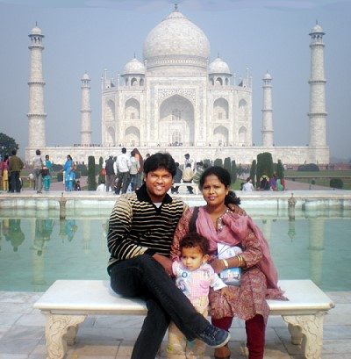
Rev. Sunny Raul
Light of Hope Mission India
www.lohamissionindia.org
Email: loh2020@yahoo.com
India

