eBlessings International Daily Devotional Archives
enrich, inspire, encourage, bless, and empower spiritual warriors for end-time battles prepared with the guidance of the Holy Spirit for spiritual growth and victory! Devotionals Designed to Empower and Grow Our Spirits
JUNE 2009 JUNE 2009 JUNE 2009
Visit DOT, and WOW Empowerment Series, plus Prophecy, Spiritual Keys & Lessons, IA, PP and more...

Each One! Bless One!
You Make a Difference!

* * * * *

Tuesday, 2 June 2009
PLEASE HELP PASTOR KHAMLANA... THANKS... ANTHONY
I greet you in the name of our lord Jesus Christ. Man of God we need prayer so that we can be able to help the orphans you see in the pictures. Because we believe that as a church we must do something that is why we need prayer so that God can open doors so we can get resources to help them. Help us to help them. Get others to help us to help them.
 | 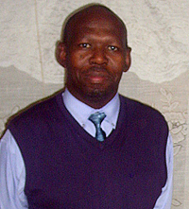 | 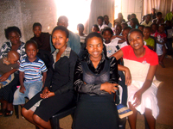
 | 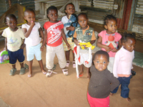 | 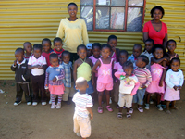
 | 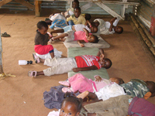 | 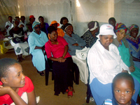
 | 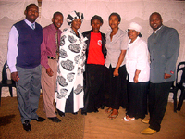 | 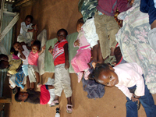
Man of God may God bless you and your family. Please help! Thanks!
Yours in Christ,
Pastor Duncan D. Khamlana
Free Gospel Fire Ministry
P. O. Box 6494; Emaphupheni; Etwatwa 1519
Benoni, Republic of South Africa, Africa
Telephone: +2711 422 3420; Fax: +2711 422 3421
Mobile: +27 82 888 1093
PLEASE HELP PASTOR KHAMLANA... THANKS... ANTHONY

