
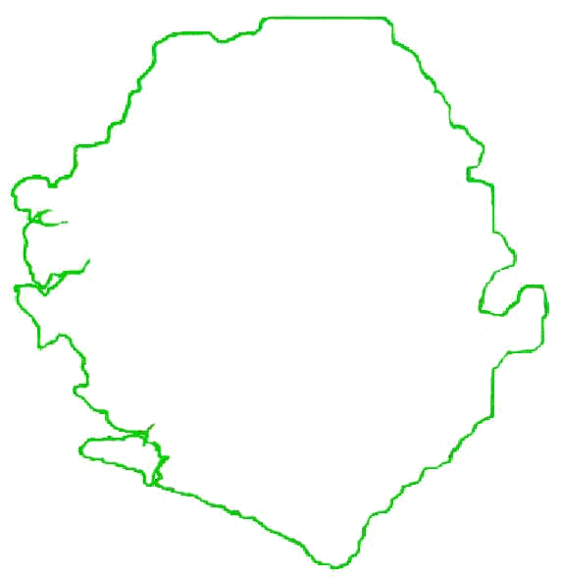
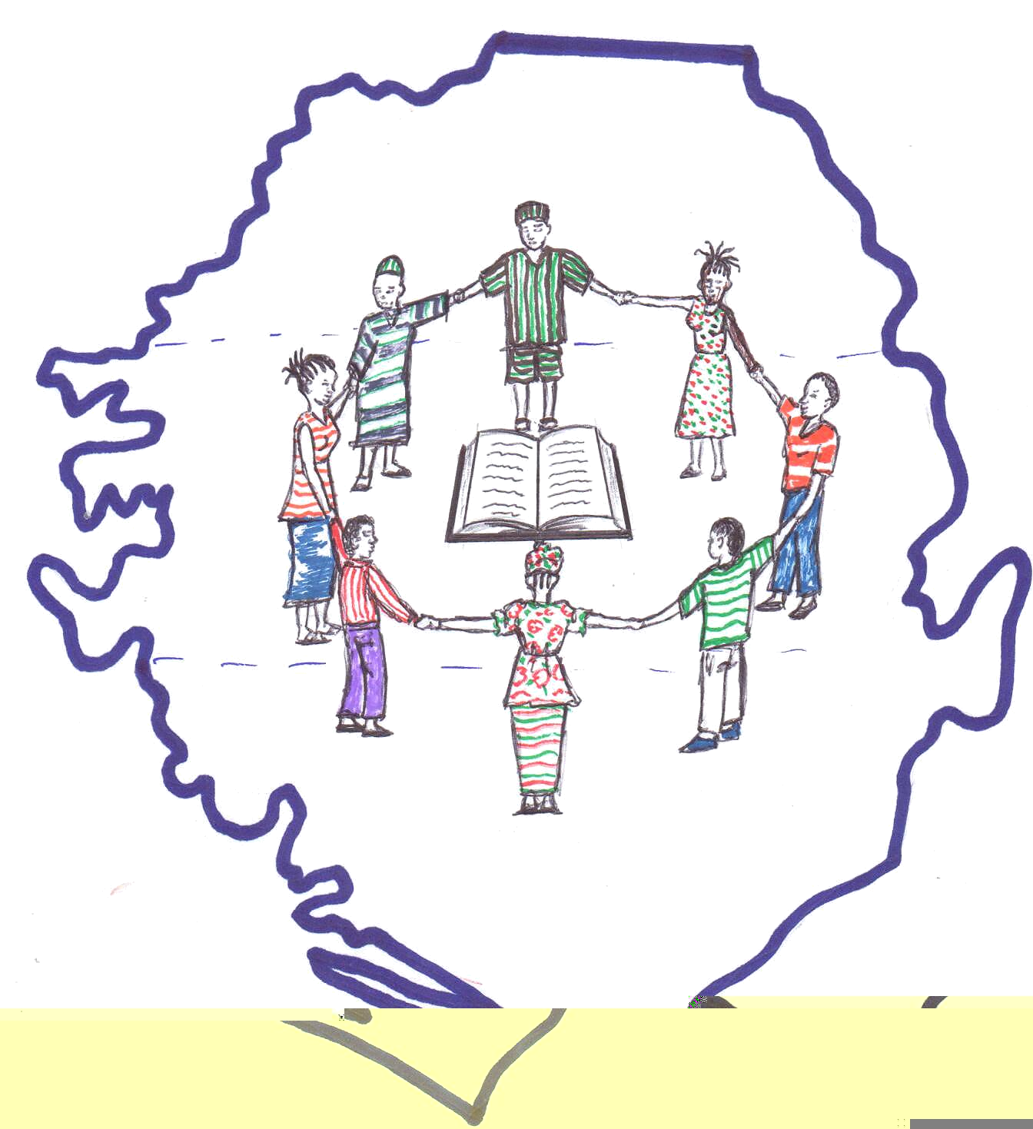
36 Musa Street, Bo - Sierra Leone - West Africa
Email: mission4salone@yahoo.com

Motto: working together to make a difference
Code Values For Mission
* Honesty * Excellence * Integrity * Service

REACHING OUT TO MUSLIMS
IN PUJEHUN & KAILAHUN

My Dear Brother Anthony,

I send you greetings from Sierra Leone and continue to bless you for all that you are joining us to do in Africa, Sierra Leone for the sake of the Kingdom. As I sent this prayer letter to you, I will also like to share some information with you about the areas that we are working in right now in our country.
Pujehun and Kailahun Districts are towns in the eastern part of Sierra Leone with a population of almost a million people and 90% of these people are Muslims. The sorrowful part of this district is these towns were once predominated by Muslims and animistic people. And one man asks, “Why are these towns dominated by Muslims?”
Two main reasons can be considered for that. One of the reasons is lack of passion and compassion for lost souls. The lack of evangelism (especially to Muslims) to the poorest and ignorant and the lack of missions by the churches. Churches are very complacent to reach out to Muslims and people in the provinces; they only concentrate in big cities, showing little or no effort in reaching out to Muslims in places like these (small villages) forgetting that they are part of the Great Commission.
The second reason is that, after the war, Muslim countries or organizations took advantage of the poor and vulnerable people in the provinces, like Kailahun and Pujehun by coming with material help like free schooling, food, and medication; and as a result many people were converted to Islam.

Generally, Islam is growing rapidly in our country and recent research shows that Islam has grown up from 60% to 70% while Christianity has dropped from 30% to 20%. This is a course for alarm. It is surprising to know that in some villages like Kailahun and Pujehun, that you can not find a single Christian, not to mention talking of a church. Yet, in every village of the districts, there is no town without a Mosque for Muslims to pray. It is a pity—we must rise. This is a big challenge for the body of Christ in the World.

CHALLENGES {Please I beg that you fine a way to help with one of these.}
The one million dollar question now is, “How can we reach these lost souls with the Gospel of our Lord Jesus Christ?” The challenges are very enormous and is high time Christians, Churches, and Christian organizations to stand up to these challenges—that is, reaching out to Muslims and the lost in Pujehun and Kailahun. In fulfilling this great task, that is why Mission 4 Salone Ministries with compassion and passion for this lost souls in Pujehun and Kailahun is taking this challenge to reach out to Muslims—though the Mission is facing challenges like very bad roads, lack of funds to help the needy in these areas and logistics.
In fulfilling the great commission in these two districts, Missions 4 Salone Ministries is in desperate need of the following:

- Vehicle: Toyota-Hilux Landcruiser or Land-Rover, because of the very bad roads in this part of the country and for the transportation of equipments and other items to the Mission Field. Such a vehicle is highly preferable for this work and the cost of this vehicle is Le17,000$ (seventeen thousand dollars)

- Bicycles: for effective movement and work of Missionaries in the villages, six bicycles are needed for missionaries in the field and each bike cost $150 (one hundred dollars) and the six bicycles cost $900 (Nine hundred dollars).

- Safe Homes: This is another important item that is needed by the mission. From time in memorial, Muslims that gave their lives to Christ were always persecuted by their parents or community to the extent of driving them out of the community, stripped of any title, disowned by their family members and friends and even to the point of threatening to be killed. So as a result, the Mission always accommodates such people (converts to Christianity) and finds a place for them. And such places are known as “safe place” and hiring of such houses cost $2,000 (two thousand dollars) per-year.

But the Mission also finds it very important to purchase some acres of land for building safe houses and the purchase of this land cost $30,000 (thirty thousand dollars). A Portable Public Address System is also needed.

In these acres of land, a multi-purpose building will also be erected and this building can be used for fellowship/church meetings and as a school (mainly Christian School) where Christian ethics will be strictly observed.

In conclusion, since our Lord Jesus Christ has given us the Great Commission in Matthew 28:18-20, Mission 4 Salone Ministries is doing its best in fulfilling this commission and in fulfilling this commission; we need partners to work with. And Mission 4 Salone Ministries has the burden and passion in reaching out to Muslims. And I pray that God will touch the hearts and minds of our partners to help in providing our needs in accomplishing this Great Commission.
This is my Challenge for you all who may have the chance to read this note. Join us in your prayers. Donate to one of these needs as the Lord will provide for you.

Yours in His service.
Peter

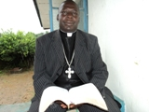
MISSION 4 SALONE
SIERRA LEONE
36 Musa Street
Bo - Sierra Leone - West Africa
Rev. Peter Kainwo
Email: mission4salone@yahoo.com
petina2441@yahoo.com

