EACH ONE! BLESS ONE! YOU MAKE A DIFFERENCE!
If Each One Will Bless One, the World as We know it Will Change!
Emmanuel’s Blessings to You! Peace and Love in Christ! PLC!
MAY 2010 MAY 2010 MAY 2010
Visit the Seal-of-God, Four-N-One, Dot, Wow, Prophecy, Keys & Lessons, IA, PP and Welcome...

Each One! Bless One!

* * * * * * *
WORLD CUP Message! Pass on! Thanks so much!


World Cup News stories videos match analysis, photos of the day, fan quotes, Christian athlete profiles, daily prayer request,s podcasts; Host Cities fast facts, city guides, meet the residents, photo galleries, stadium shots. Resources, video prayer guides, bulletin inserts, prayer cards, evangelism and outreach tools, fun kids materials. SOUTH African World Cup Fever: diski dance, leopard-like mascot, crazy noisemakers, incredible hats, Ministries blogs, video features, on-site reports, prayer updates, involvement opportunities, AND MORE.

Take a Journey to South Africa for the Soccer World Cup
www.WorldSoccerJourneys.com

An exciting website, www.WorldSoccerJourneys.com, will be reporting on ministries, matches and prayer updates throughout the FIFA World Cup in South Africa . Stories, photo galleries and videos will be produced on many volunteer teams doing ministries during the World Cup, including yours! See the attached PDF for details.

Please share about this website with your church, school, families and friends. Encourage them to check the site regularly throughout the World Cup for stories about what’s happening in South Africa -- they may even see you on the site!
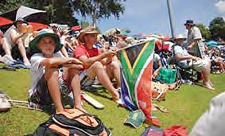 |  | 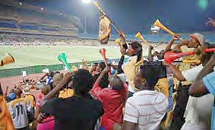

Free promotional cards are available for order at: http://www.imbresources.org/index.cfm/fa/store.prod/ProdID/2948.cfm

You can also follow World Soccer Journeys on Twitter and Facebook:
www.twitter.com/wsjourneys
www.facebook.com/wsjourneys

THANK YOU FOR SUPPORTING THE WORLD CUP


Minister George F. Blamoh
National coordinator, Athletes in Action-Liberia
(An eBlessings Outreach Partner)
P.O. Box 10-520
90 Tubman Boulevard
Monrovia, Liberia
Mobile: +231-6576445
Email: georgeblamoh@yahoo.com

