eBlessings International Daily Devotional Archives
enrich, inspire, encourage, bless, and empower spiritual warriors for end-time battles
prepared with the guidance of the Holy Spirit for spiritual growth and victory!
Devotionals Designed to Empower and Grow Our Spirits

OCTOBER2008OCTOBER2008OCTOBER2008
Visit DOT, and WOW Empowerment Series,
plus Prophecy, Spiritual Keys & Lessons, IA, PP and more...

Each One! Bless One!
You Make a Difference!

* * * * *

Dear Brother James Anthony Allen,
I would like to dedicate this August update to our dear friend and Pastor D B Rai who went to be with the Lord in September, 2008.

DB Rai was second key leader in our Churches Network. He dedicated his whole life to Jesus and the gospel and served the lord for more then 20 years without any gain and profit. The contribution he made in the kingdom of God is without of measure. He brought countless lives to Jesus, baptized hundreds of people, organized many programs and games that carried out the gospel. The Lord's Hand and grace was upon him. He started many work but have not completed it. He has a wife and a son Adam who is 14 and is studying in Class 8 and daughter Anisha who is 12 and is studying in class 5. He was constructing new Church building just to contain more members. He was the man of the house and fed his family. He is no more now and left behind family do not have any source of income.
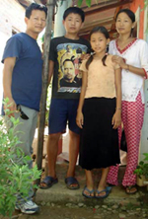
After his death, one question hit my mind. This was 'what will a pastor get to feed his family when he is finish?' If you were a british gurkha you will receive a pension every month. But, to left behind family like DB Rai family, it is very hard to imagine. It is very easy to say God will take care of them.
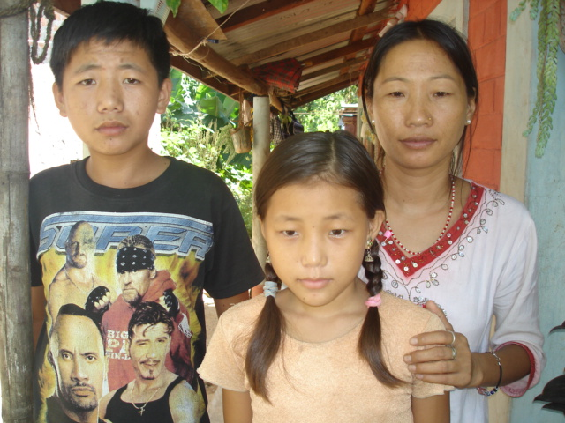
So let us join with this family in times of need such as this. Let's pray for

- Finance for: Adam and Anisha to go to School at least 20 dollar per month.
- Complete the Church building by putting metal roof and concrete floor.
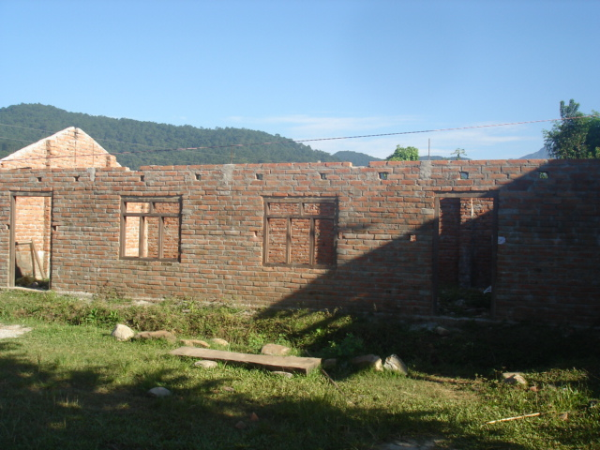
- Organize DB Rai Evangelistic Interchurch soccer tournament.

I am willing to answer you any question related with them and these programs. Let's show true spirit of friendship and encouragement to this bereaved family. I believe this is service and this is ministry.

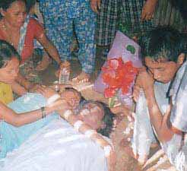
How he died?
He had pressure and for almost a year he had not checked it up. 9PM they ate dinner, at 11pm they went to the bed and at 12am, he stretched his body and breathes a long breath. Many tried to wake him up but he did not return. They rush him to the hospital and the doctor told them this is too late. No body believed this at first, but this is the story. We feel very sorry we missed him. DB and I were planning to hold open air gospel crusade in coming December now this responsibility have transfer to my head.
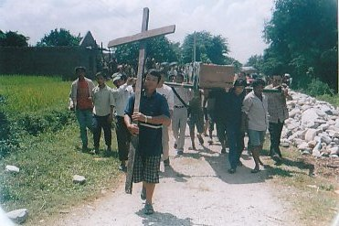
Today brother DB is with God. We don't know when our turn comes. But until then let us continue to serve God by telling people about Jesus Christ. I will send Sept-Oct combine report with photos at this month end. We would like to request you to pray for following needs we have.

- 450 Nepali Bibles to give away to needy people.
- 10 Bycycle to our workers and evangelists.
- 13 Guiters for gospel outreach program and worship.
- 15 Sleeping Bag for pastors & evangelists when traveling village to village.
- Fund to organize December Outreach Program.
- A motorbike for me.
- A lap top for me to use while traveling and ministering.

We appreciate you for taking your precious time to read this news update. We really need your prayer and assistance to carry out the gospel. Nepal is one of the countries in the world which still sleeps in total darkness and needs Jesus' light. You and I are the one to lead thousands of people to the Cross of Jesus. Among the hundred hardly two are Christians in Nepal. For this reason Jesus delays His return so that people might know the Lord of all.

Thanking you for standing with us.
Reuben


Pastor Reuben & Rita Rai
Balkumari Apostolic Mandali
GPO 8975 EPC 2030
Kathmandu, Nepal
Email: tankrai@gmail.com, reubenrita@yahoo.com; newjourneyinchrist@hotmail.com
Web site: www.churchesnetwork.com / www.freewebs.com/reubeninnepal
Phones: (0977) 98510 12105, (0977) 9841618428

