eBlessings International Daily Devotional Archives
enrich, inspire, encourage, bless, and empower spiritual warriors for end-time battles
prepared with the guidance of the Holy Spirit for spiritual growth and victory!
Devotionals Designed to Empower and Grow Our Spirits

SEPTEMBER2008SEPTEMBER2008SEPTEMBER2008
Visit DOT, and WOW Empowerment Series,
plus Prophecy, Spiritual Keys & Lessons, IA, PP and more...

Each One! Bless One!
You Make a Difference!

* * * * *

EXCERPT FROM IJAC?: IS JESUS A CRACKHEAD?

CHAPTER
16

Walking with Christ Jesus Daily

“Stand fast therefore in the liberty wherewith Christ hath made us free, and be not entangled again with the yoke of bondage. “
Galatians 5:1

Life is about not being bound by the Old Testament covenant, but being free in the New Testament covenant, Jesus Christ. Galatians 5:1 is quite appropriate for this chapter—not being tangled up with your old self, but in a new relationship in Christ.

satan. Words have power. Don’t give the enemies of God any power, any time, anywhere. Don’t give satan any respect. Don’t give him any time, not a moment.

Keep his name a lower case “s,” a little “s.” Because that is all he is, a little “h” (he, heathen), a little “s” (satan), and a little “d” (devil, demon). He walks around like a lion—not like a huge, powerful, beast of the wild (elephant, tiger, hippopotamus, or rhino), but he’s just a little cat; “meow, meow.” This is an exaggeration, but you get the picture.

The devil can do to you only what you allow him to do to you and what God allows him to do to you. Do not allow him to do anything to you or your family.

Heavenly Hierarchy. Let me share with you what the Holy Spirit shared with me about the Heavenly Hierarchy. This is powerful—do not ever forget this. In church one day, the Bishop of the church said that he was going to teach us how to be empowered in the LORD. He went on to say, “increase the amount you give in your tithes and offerings and you will be empowered.” My spirit knew that was not correct. So I asked Jesus to show me how to empower people and how to be empowered.

A few days later in my study of the Bible, the Holy Spirit directed me to this scripture:

“For we do not wrestle against flesh and blood, but against principalities, against powers, against the rulers of darkness of this age, against spiritual hosts of wickedness in heavenly places.”
Ephesians 6:12 (NKJV)

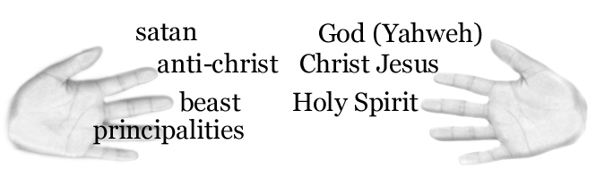 Spiritually, I focused on the Heavenly Hierarchy: Father God, Yahweh (the Creator of all), His Son, Christ Jesus, Emmanuel (Saviour of the world) and the Holy Ghost (the Comforter, the Holy Spirit of God). Then I thought about the opposite of that, the evil hierarchy (or evil lowerarchy): satan (leader of evil in the world) (Revelation 12:9), the antichrist (spirit of anti-Christ) (1 John 2:18, 4:30), and the beast (Revelation 11:7, 13:1) (representing world systems).

My focus was on the Hierarchy and lowerarchy because the word “principalities” stood out in the Ephesians passage; and in an effort to place the entity in a power hierarchy, I searched for hierarchies in the Bible. I then asked my pastor what the principalities of God were. The answer was: “We are the principalities of God.” I didn’t buy that one. I could tell the question caught him off guard and the Holy Spirit in me did not bear witness to his answer.

I asked another pastor the question and he told me: “God does not have principalities. Principalities are evil.” My spirit bore witness to him on that but I knew in my spirit that God would have something at least equal to evil principalities.

Arch-Angels are not equal to principalities; nor are Angels—then what was, I asked the Holy Spirit? One night as I was reading my Bible, I read:

“But the fruit of the Spirit is love, joy, peace, longsuffering, kindness, goodness, faithfulness, gentleness, self-control. Against such there is no law.”
Galatians 5:22-23 (NKJV)

When I finished reading this scripture, it was as though I hadn’t read it. So I read it again, because I knew in my heart, (my spiritual heart, not to be confused with emotions or feelings) that I had missed something. I have learned, when I am reading something or doing something and I do not remember reading it or doing it, that the Holy Spirit or an Angel is with me, illuminating me to see something specific or to do something specific, that I didn’t see or do the first time. I have learned to ask them to let me see the spiritual or do the spiritual through “spiritual” eyes (vision) or “spiritual” feet (direction). So I read it again.

This time as I read it, the Holy Spirit let me see in my mind’s eye an apple tree. In my spirit, I knew the apple tree represented the Holy Spirit. And the scripture said, “the fruit of the Spirit…,” so I knew the fruits of the Spirit were the apples on the tree. And I believe that the fruits of the Spirit are the next level down on the Heavenly Hierarchy. “Love” is one of the fruits of the Spirit. Well I know that the scripture says, “God is love.”

“He who does not love does not know God, for God is love.”
1 John 4:8 (NKJV)

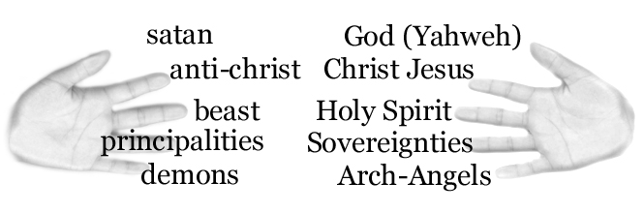
So now I equate “love” as not only a word, not only a fruit of the Spirit (Holy Spirit) being under the Holy Spirit in the Heavenly Hierarchy, but “Love” as being a powerful entity bearing the characteristics and attributes of God.

Love is one of the fruits of the spirit and is at least as powerful as the evil principality, but there are others, too; namely in the King James Version of the Bible: joy, peace, longsuffering, gentleness, goodness, faith, meekness, and temperance. The Holy Spirit allowed me to be illuminated with this mystery, this Divine Knowledge, this Divine Wisdom of the authorities of God. I refer to them as “Sovereignties” because they are sovereign, powerful, and cover great distances of time and space. When speaking about Jesus being in Heaven, the Bible refers to them as “authorities”:

“Who is gone into heaven, and is on the right hand of God: angels and authorities and powers being made subject unto him.”
1 Peter 3:22

The Saint Joseph “New Catholic Edition” of the Holy Bible refers to them as virtues:

“who is at the right hand of God, swallowing up death that we might be made heirs of eternal life: for he went into heaven, Angels, Powers and Virtues being made subject to him.”
1 Peter 2:22 (SJ)

I now know that there is God, Jesus, the Holy Spirit, and the Authorities, (fruit of the Spirit (Galatians 5:22); what I will refer to as Sovereignties). Sovereignties are the opposite of evil principalities. Now we approach the part of this equation where mankind comes in. Under Sovereignties in the Heavenly Hierarchy, let us say, Arch-Angels, and then Angels. Under evil principalities, let us say, there are powers and demons.

For the sake of this discussion, we will not group: spiritual wickedness in high places, rulers of darkness of this world, or a host of other evil entities. Nor will we discuss or include: powers, thrones, Dominions, Hosts, Acons, or a host of good entities.

The question is where does man come into the picture? Where does man fit into the Heavenly Hierarchy? People say, we are a little lower than Angels or we are just above the Angels. What does the Bible say?

“For thou hast made him a little lower than angels, and hast crowned him with glory and honour.”
Psalm 8:5

This is what satan would have you believe and to hold on to. Give me a minute here and I will break it down for you. Stay with me. Where does satan belong in the evil hierarchy (lowerarchy)? You say at the top—opposite God? Right? WRONG! That is a big WRONG!

What was satan when he was in Heaven? He was an Arch-Angel. Where do Arch-Angels rank? Below fruits of the Spirit; Sovereignties and Authorities. Okay, so now you know that he is not equal to God on the hierarchy playing field. His whole hierarchy (lowerarchy) scale is to be shifted down in our hearts and minds.

Now, let me ask you again. Where does man fit into this equation? A little lower than Angels is for those members of mankind who do not believe and serve God through Jesus Christ. For believers, the Bible says:

“Behold, what manner of love the Father hath bestowed upon us, that we should be called the sons of God: therefore the world knoweth us not, because it knew him not.”
1 John 3:1

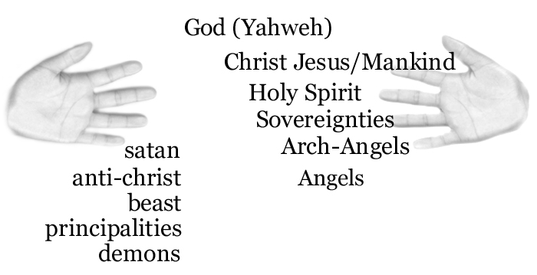
We are the sons and daughters of the Lord God Almighty. (Romans 8:19; Galatians 4:6; Philemon 2:15; 1 John 3:2) Jesus is our brother. God is our Father. When we are not saved, we are a little lower than the Angels. But when we are saved, then we are above the Arch-Angels and on the same level as Jesus, being children of God.

Now you see why I said remember this. Satan wants us to think that he is all-powerful and has dominion over us. He does not. He is our footstool. (Psalm 110:1; Matthew 22:44) We are above him in the hierarchy of God’s Creation. We have to remember that and walk with that. Live with that knowledge in your heart.

END OF EXCERPT FROM IJAC?


James Anthony Allen Born-Again, Holy Ghost-filled, Tongue-speaking, Lion of Judah, Evangelist and US Patriot
http://www.eBlessings.us ; eBlessings@gmail.com
Stone Mountain, Georgia, USA, North America

