EACH ONE! BLESS ONE! YOU MAKE A DIFFERENCE!
If Each One Will Bless One, the World as We know it Will Change!
Emmanuel’s Blessings to You! Peace and Love in Christ! PLC!
Visit the Seal-of-God, Four-N-One, Dot, Wow, Prophecy, Keys & Lessons, IA, PP and Welcome...

Each One! Bless One!

* * * * *
Northern Lights seen as far south as Michigan after Sun's 'solar tsunami' but no sightings reported in the UK ... yet
By Niall Firth
Last updated at 10:34 AM on 5th August 2010

Skywatchers in the UK have again been denied the chance to witness the Northern Lights after missing out on the spectacular sight last night. Lancaster University's Aurora Watch detected 'no major activity', despite the series of massive explosions on the Sun that sent waves of supercharged gas hurtling 93 million miles towards the Earth.

Parts of northern America, in particular the state of Michigan, were lucky enough to be given clear skies the previous night and managed to catch the incredible display.
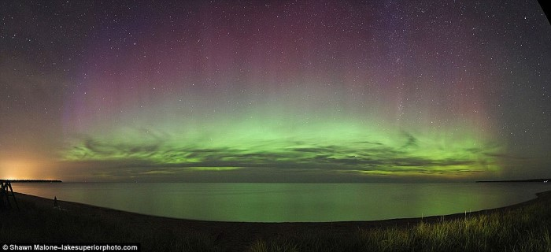
A stunning panoramic image of Lake Superior in Michigan taken by photographer Shawn Malone of Marquette last night. Michigan was one of the US states which were lucky enough to get a full aurora borealis display last night as the solar tsunami disturbed the Earth's magnetic field.

And David Gavine, the director of the British Astronomical Association's Aurora division, said that there is every chance the UK might have been able to see similar views last night after Denmark enjoyed wonderful views on Tuesday night. The sighting in Denmark was significant because it is on much the same geomagnetic latitude as the UK, which determines how far south the aurora is visible. 'So there's every chance, if the skies are clear that we might see something tonight, ' Mr Gavine had said. Even though northern states like Michigan are far further south than the UK they are still more likely to see the Northern Lights.
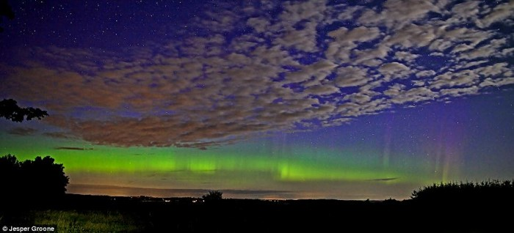
A stunning photo pf the aurora over Denmark at 1am last night by photographer Jesper Groone outside his house.
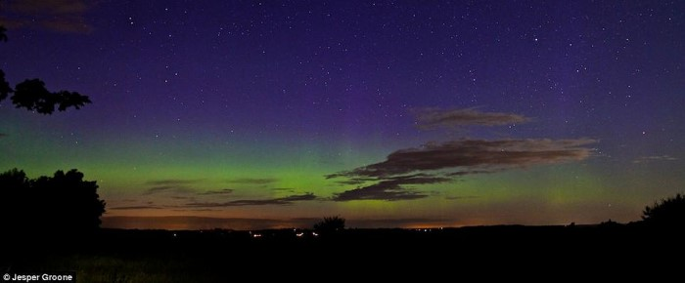
Jesper Groone used Canon 5D II camera to take his shots of the Northern Lights on the horizon. Denmark is on the same geomagnetic latitude as Scotland
This is because the aurora appears along Earth's geomagnetic latitude rather than geographic latitude.

Earth's geomagnetic Pole is based in northern Canada rather than the North Pole meaning the viewable zone for aurora is tilted so that northern states in the US are much more likely than the UK to see a display. The prospect of seeing the aurora borealis from the UK is because two minor solar storms that flared on Sunday are shooting tons of plasma directly at Earth. Really big solar eruptions can destroy satellites and wreck power and communication grids around the globe.

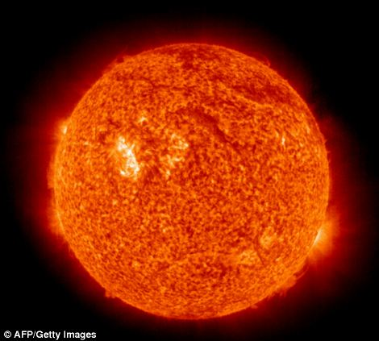
Usually only regions closer to the Arctic can see the aurora of rippling reds and greens, but solar storms pull them south. Early on Sunday morning, the Sun's surface erupted and blasted tons of plasma - ionised atoms - into interplanetary space. 'This eruption is directed right at us, and is expected to get here early in the day on August 4th,' said astronomer Leon Golub of the Harvard-Smithsonian Center for Astrophysics (CfA). 'It's the first major Earth-directed eruption in quite some time.'
A map which shows the magnetic latitude of the Earth and the position of Michigan in relation to London and Denmark. The sun's recent activity and solar flare has led to the recent activity in the Earth's atmosphere. The eruption, called a coronal mass ejection, was caught on camera by NASA's Solar Dynamics Observatory (SDO) - a spacecraft that launched in February. SDO provides better-than-HD quality views of the Sun at a variety of wavelengths. 'We got a beautiful view of this eruption,' said Golub. 'And there might be more beautiful views to come, if it triggers aurorae.'

When a coronal mass ejection reaches Earth, it interacts with our planet's magnetic field, potentially creating a geomagnetic storm. Solar particles stream down the field lines toward Earth's poles. Those particles collide with atoms of nitrogen and oxygen in the atmosphere, which then glow like miniature neon signs. Aurorae normally are visible only at high latitudes. However, during a geomagnetic storm aurorae can light up the sky at lower latitudes.

There is still a possibility of geomagnetic activity being seen tonight. Sky watchers should still look toward the north this evening for rippling curtains of green and red light. The Sun goes through a regular activity cycle about 11 years long on average. The last solar maximum occurred in 2001. Its latest minimum was particularly weak and long lasting. This eruption is one of the first signs that the Sun is waking up and heading toward another maximum.

The storms are not expected to be much of a threat to satellites or power grids.
Dr Robert Massey of the Royal Astronomical Society said: "You do see the aurora occasionally in England, although it's most often seen in Scotland.'
Dr Lucie Green of the Mullard Space Laboratory at University College London said: 'It now looks like there were five eruptions on Sunday within a 20 hour period.

'We have seen the effects of the first of these. It depends how fast they travel, but if they are moving slowly, we could still see some effects on Thursday night.
'If you see aurora in England it's a very special event but in the north of Scotland it might be worth having a look.'

Read more: http://www.dailymail.co.uk/sciencetech/article-1300175/SOLAR-TSUNAMI-Northern-Lights-seen-far-Michigan-Suns-flare.html#ixzz0vjY6zpjP

